**FISHER HALL**

**WELCOME WEEKEND BOOKLET**

**2019-2020**

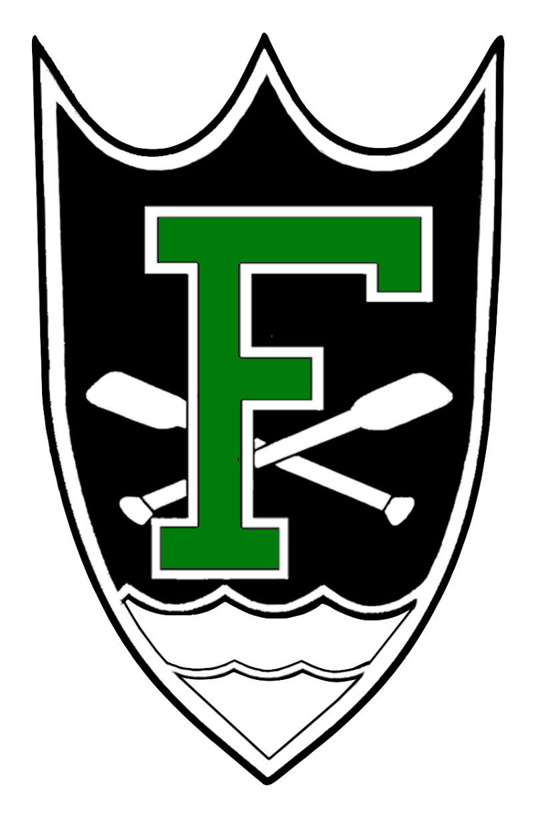

*Table of Contents*

From the Desk of the Welcome Weekend Captains

Meet the Staff: Mazz

Meet the Staff: AR’s and RA’s

Meet Hall Government

Meet the Captains

Meet the Ambassadors

Rooms

Ellie’s Deli

Brother and Sister Halls: O’Neill and Badin

Service

Athletics

Events: Fisher Funk

Events: Fisher Regatta

ND Jargon Dictionary

Nearby Stores/Restaurants

Useful Websites

# From the Desk of the Welcome Weekend Captains

Welcome New Fishermen!

As Welcome Weekend Captains, we are happy to be in charge of your introduction to the family of Notre Dame, and of Fisher Hall. Here at the Cadillac of Dorms, we boast a long history of excellence in academics, athletics, and service. But more than anything, we are proud of our unyielding sense of community as we live out our motto that “all are welcome in this place.”

Regardless of your background or your story, you belong at Notre Dame, and you especially belong in Fisher Hall. Our job as Welcome Weekend Captains is to show you all that the University and the hall has to offer, and invite you into a something that is more like family than friendship.

With our rector, hall staff, hall government, and the Fisher community at large, one thing is true: we work hard together and we play hard together. As the most accomplished group of first-years to enter Fisher, we are sure that you will play an integral role in continuing the legacy of Fisher as the greatest hall on campus.

We all feel that Fisher Hall is a special place of good work and good fun, of friendship and family. We cannot wait for you to begin your time here, starting with an experience that you will never forget: Welcome Weekend.

Welcome home,

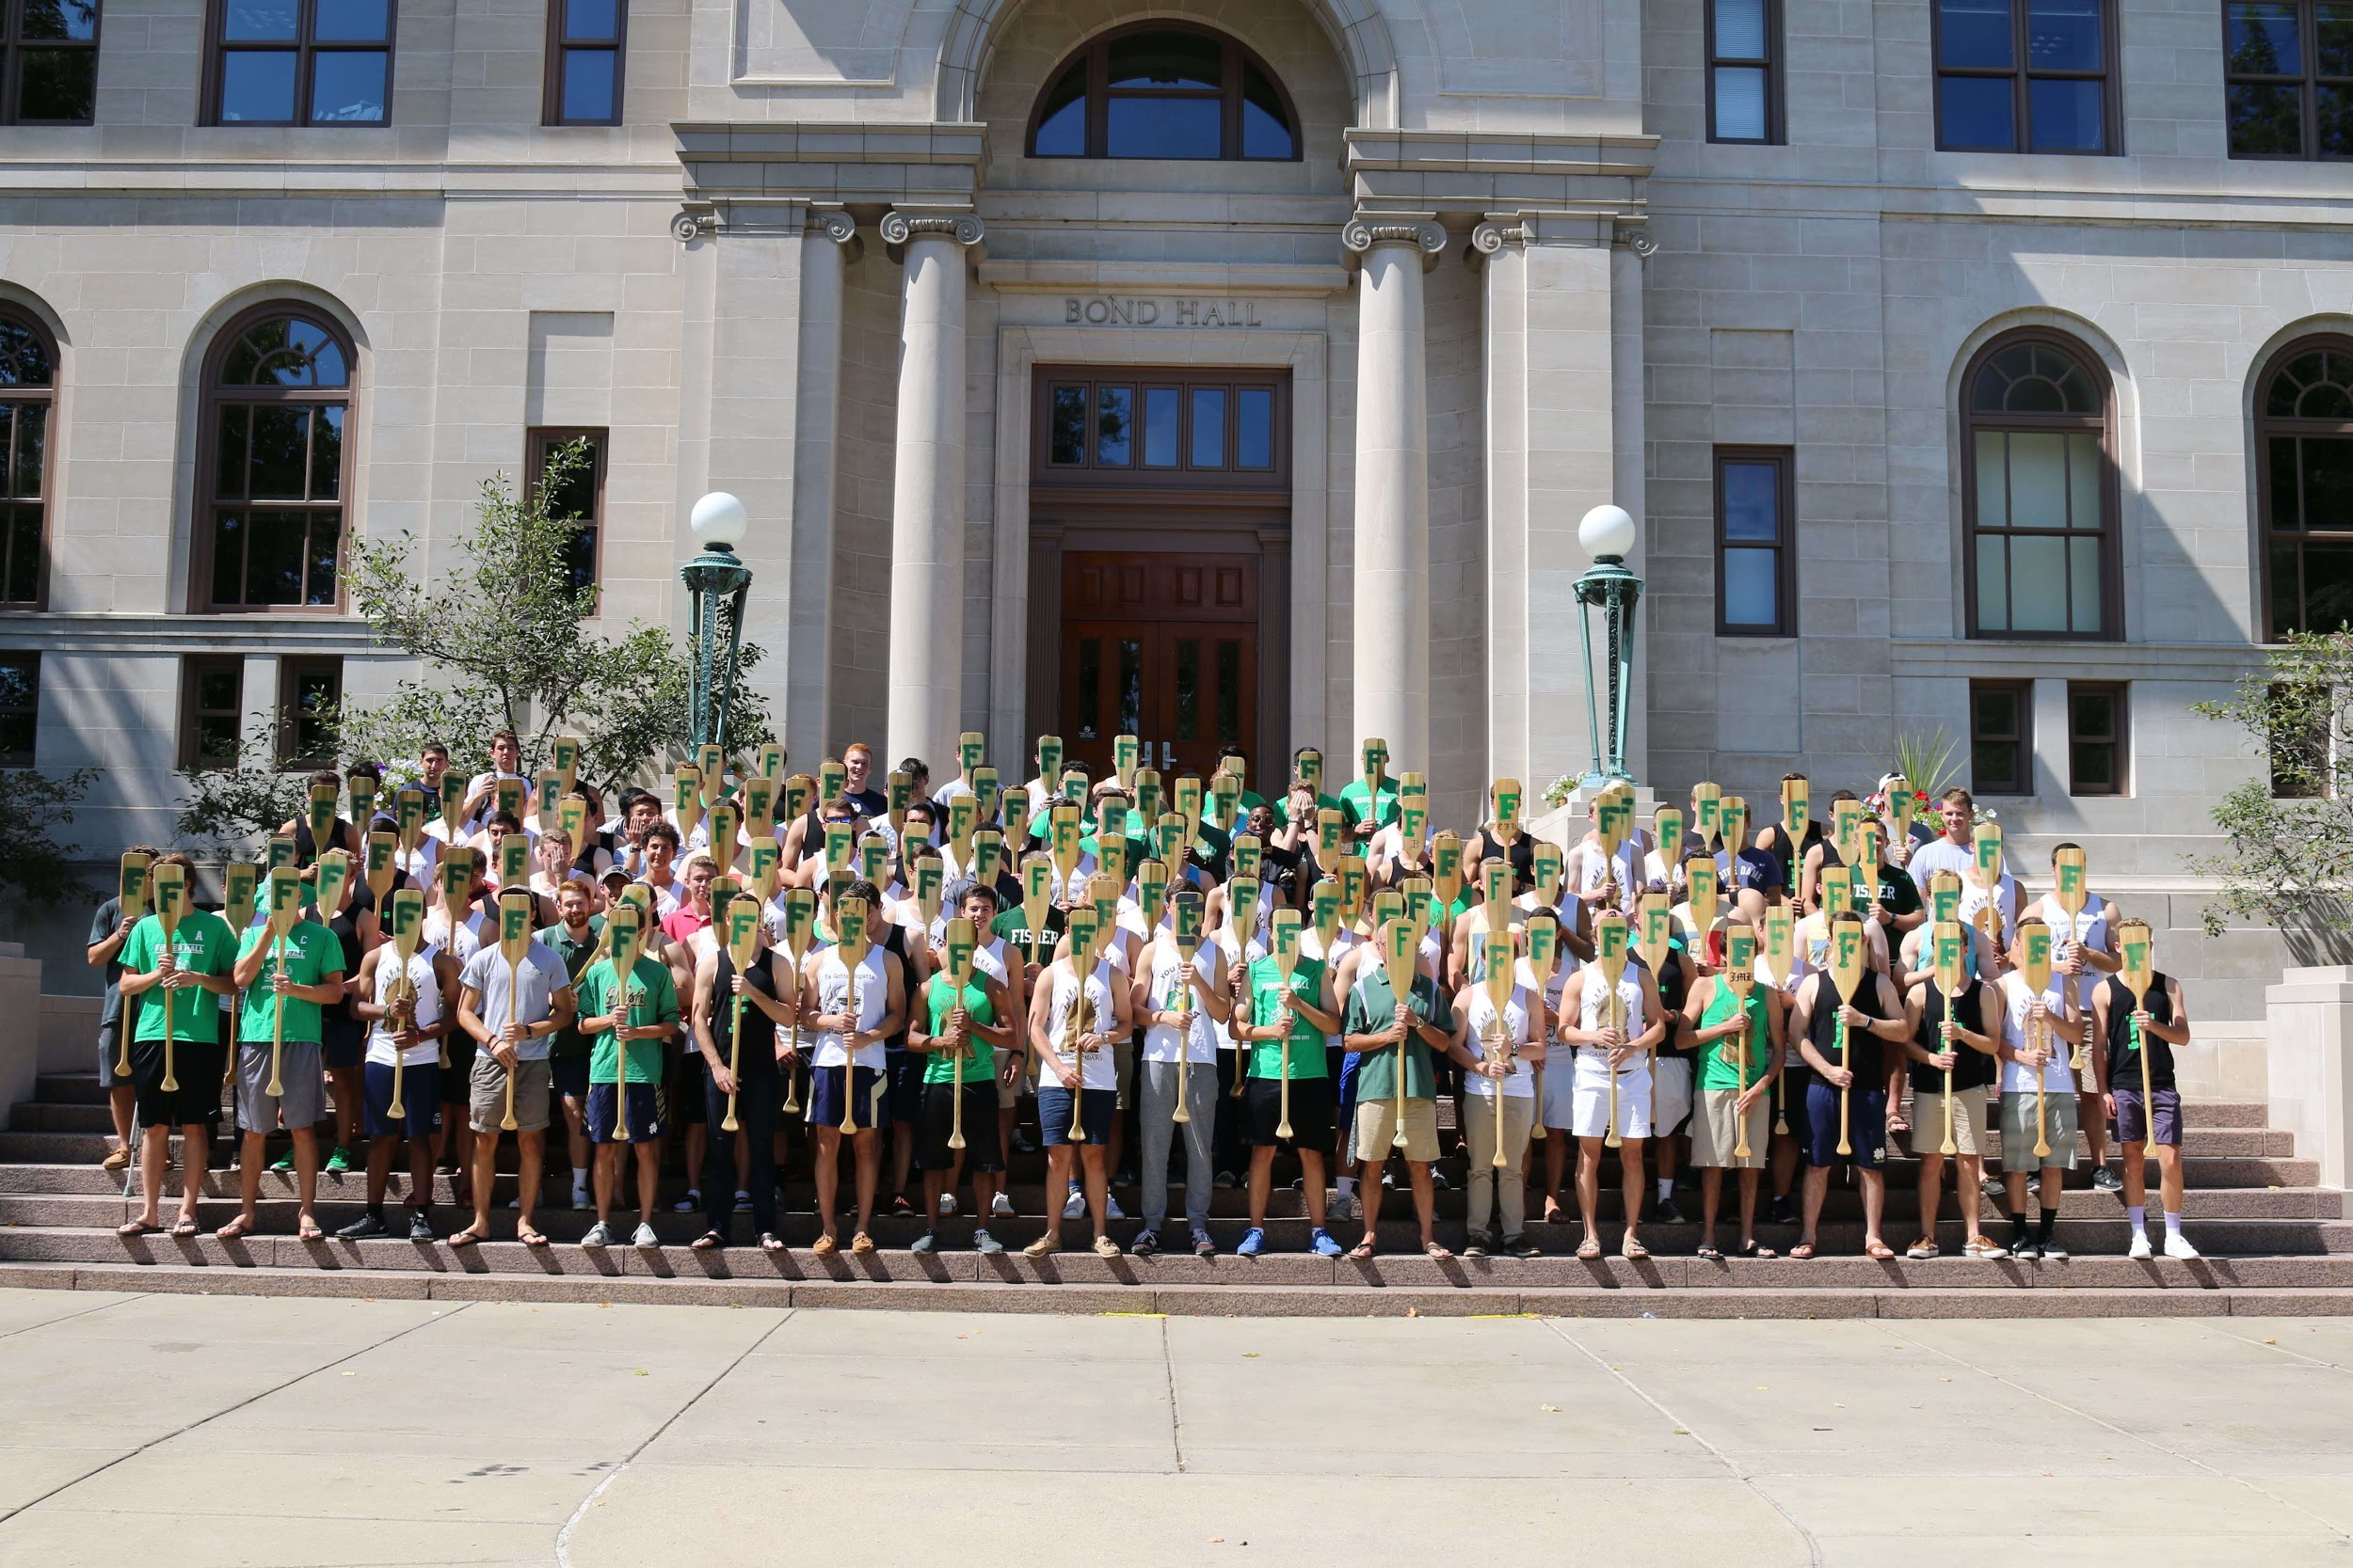Noah and Connor

# Meet the Staff: Mazz

Rick “Mazz” Mazzei became the rector of Fisher Hall in 2014. He is a Massachusetts native who holds a Bachelor’s degree in Business Administration from Notre Dame and a Master’s degree in American History from Salem State University. Prior to becoming a rector, Mazz worked as an educator and coach in Massachusetts for nearly 40 years. He is a civil war buff and enjoys traveling. On any given day in Fisher, he can be found riding marathon distances on his stationary bike, watching a Bruins game with an open door, hosting a hotdog social after daily mass, or otherwise enjoying living in community with his residents. Mazz is a member of the New England Lacrosse and Beverly High School Halls of Fame, and was the first coach in the state of Massachusetts to record 400 wins.

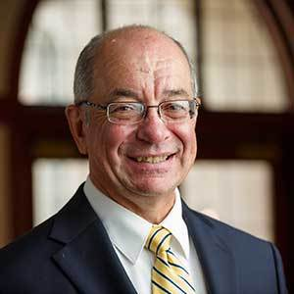

"Freshmen Fishermen: welcome to your new home. Fisher is a Hall where we stress Family, Spirit, Honor, and Respect. Fisher is a place where doors are always open, everyone is known by Name, and we are proud of our Fisher Brotherhood. Soon you will receive an email from me with more information. Enjoy your summer." -Mazz

# Meet the Staff: AR’s and RA’s

AR = Assistant Rector, RA = Resident Assistant

A Section = Rooms X01-X21, B Section = Rooms X26-X41

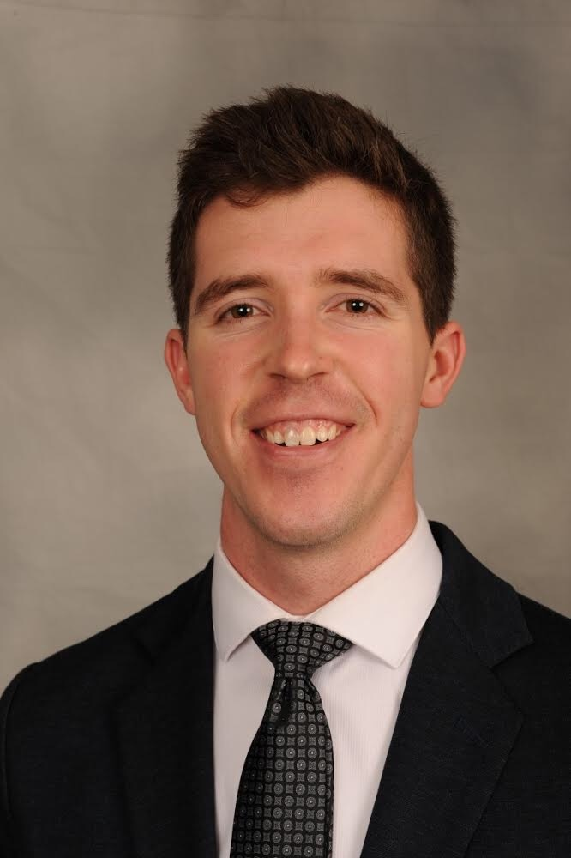

**Name**: Christopher Johnson

**Hometown:** Minneapolis, MN

**Major:** Law

**Hobbies/Interests:** Climbing, Coffee, Technology

**Fisher Section:** 4th Floor AR

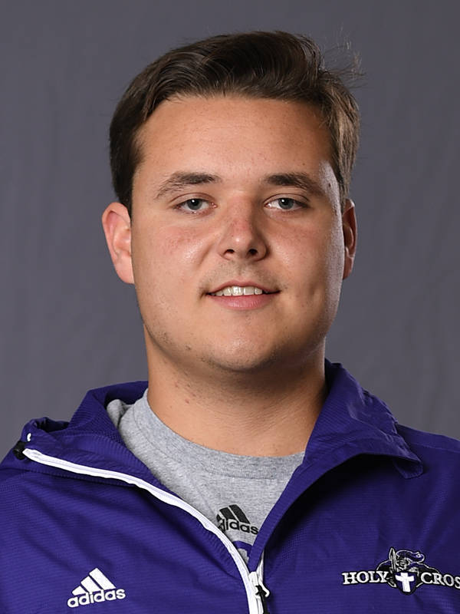

**Name**: Kyle Cunningham

**Hometown:** Wilmington, MA

**Major:** Law

**Hobbies/Interests:** Track and field, fitness

**Fisher Section:** 3rd Floor AR

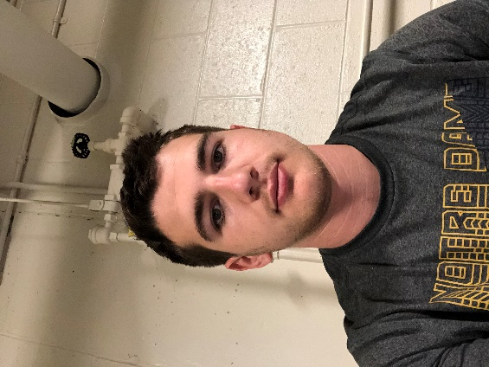

**Name:** Johnny Ostrowski

**Hometown:** Atlanta, GA

**Major**: Biology

**Hobbies/Interests:** Soccer/Smash Bros

**Fisher Section:** Basement RA

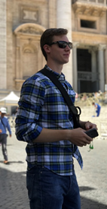

**Name:** Frank, Dijak

**Hometown:** Crown Point, IN

**Major:** CHEG/Pre-Med

**Hobbies/Interests:** The Office, Parks and Rec, New Girl, Basketball

**Fisher Section:** 1st Floor RA

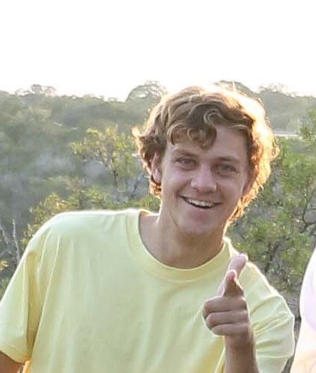**Name:** Robbie Kee

**Hometown:** San Antonio, TX

**Major:** Program of Liberal Studies

**Hobbies/Interests:** San Antonio Spurs basketball, Will Ferrell movies, Dave Chappelle stand up, William B. Travis Documentaries, Trivia about 16th century colonial missions in south Texas, remembering The Alamo

**Fisher Section:** 2nd Floor RA

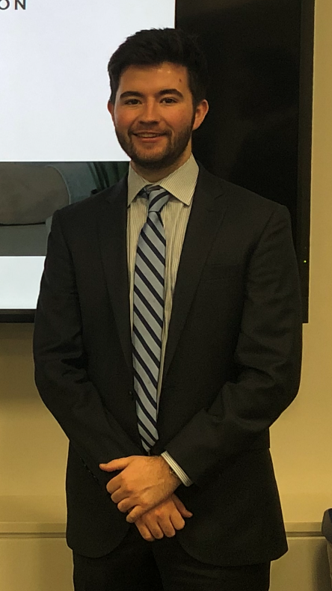**Name:** Owen Harte

**Hometown:** Long Island, NY

**Major:** Science-Business and Spanish

**Hobbies/Interests:** Playing ukulele, watching rock climbing documentaries, playing basketball, discussing why the Alamo isn’t that cool despite what fellow RA Robbie Kee will tell you

**Fisher Section:** 3rd Floor RA

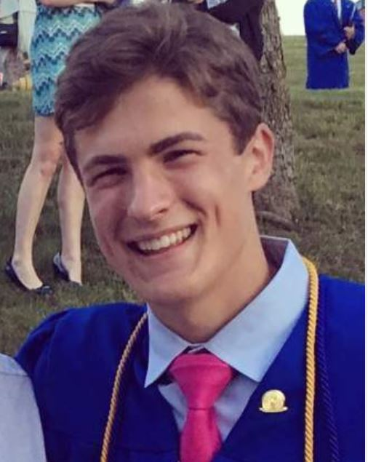**Name:** Alex Gerbo

**Hometown:** Sandy Hook, CT

**Major:** Mechanical Engineering

**Hobbies/Interests:** Basketball, Singing, football, music

**Fisher Section:** 4th Floor RA

# Meet Hall Government

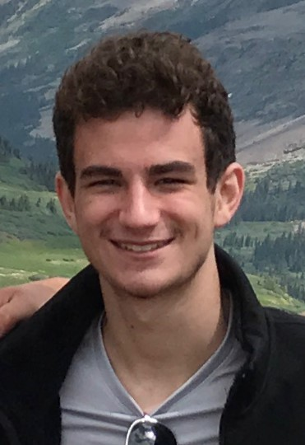

**Name:** Joe Stuppy

**Hometown:** Overland Park, KS

**Major:** Chemical Engineering/Pre-Med

**Hobbies/Interests:** Founding "Father" of Fisher Hall, Hockey, Hiking, Skiing, Patrick Mahomes

**Fisher Section:** 2B

**Role:** President

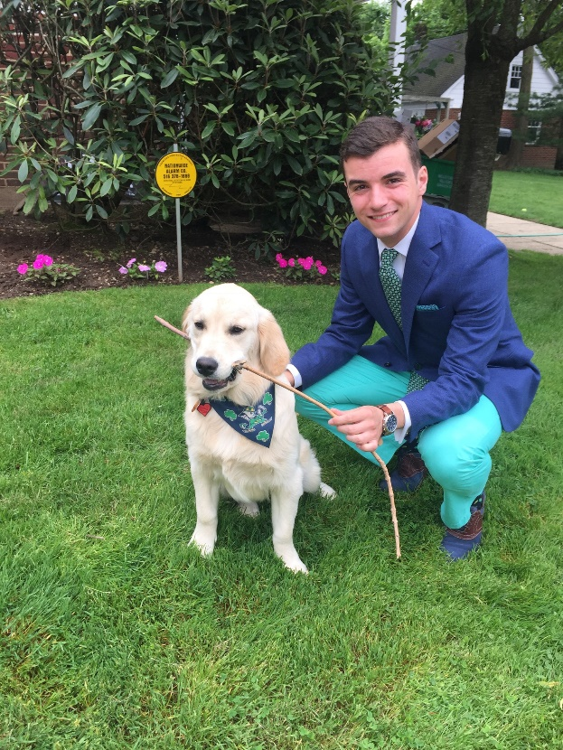

**Name:** Chris Mercadante

**Hometown:** Garden City, NY

**Major:** Economics and Spanish

**Hobbies/Interests:** Iconic Long Island landmarks, Catalonian nationalism, Piggly Wiggly wholesale grocers, whatever Meniscus just found in the dumpster out back, ND soccer

**Fisher Section:** 1A

**Role:** Vice President

# Meet the Captains

These juniors will be leading Fisher’s Welcome Weekend!

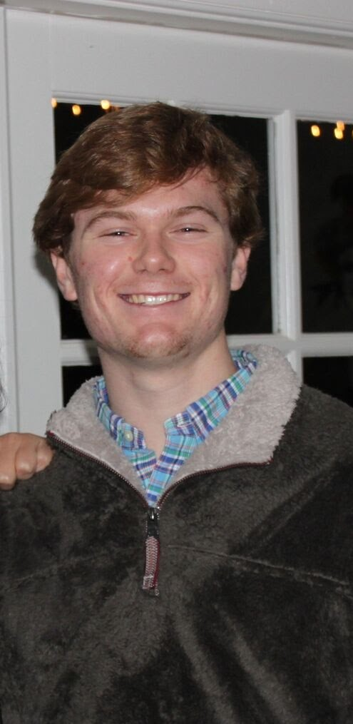

**Name:** Noah Martin

**Hometown:** New Orleans, LA

**Major:** Mechanical Engineering

**Hobbies/Interests:** New Orleans, being washed up, sleep, lacrosse, everything car related

**Fisher Section:** 4B

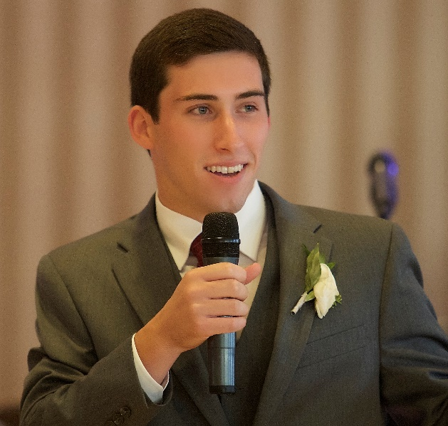**Name:** Connor Delaney

**Hometown:** Danvers, MA

**Major:** Computer Science

**Hobbies/Interest:** Late night discussions, Transcendentalism, glacial movement, Noah Martin

**Fisher Section:** 1B

# Meet the Ambassadors

These sophomores will be aiding Fisher’s Welcome Weekend!

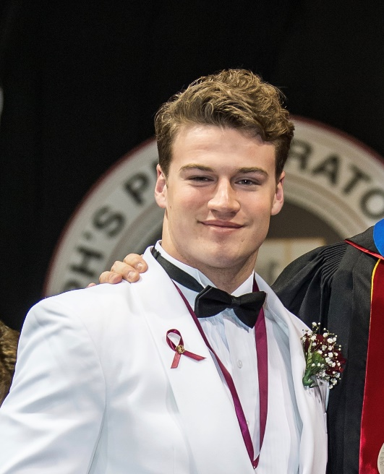

**Name:** Jake Feehery

**Hometown:** Media, PA

**Major:** Computer Science

**Hobbies/Interest:** Eating Dirt, Bedazzling Jeans, Maps

**Fisher Section:** 2A

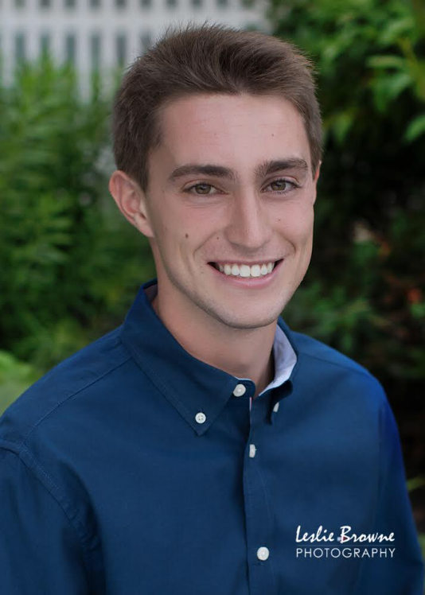

**Name:** Billy Porter

**Hometown:** Walpole, MA

**Major:** Computer Science

**Hobbies/Interest:** Taxidermy, fly-fishing, backgammon, pinball, WWE announcing

**Fisher Section:** Basement

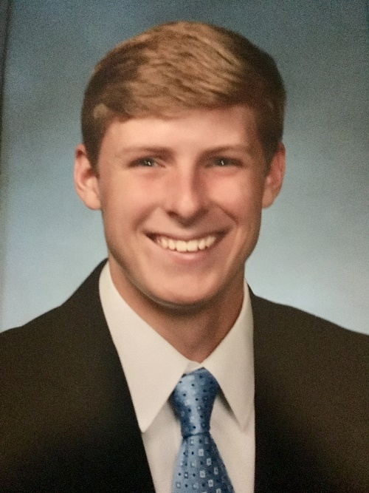

**Name:** Conor Donlevy

**Hometown:** Hinsdale, IL

**Major:** Political Science

**Hobbies/Interest:** Sports, Fishing Mario Super Sluggers, Wii Tennis, Mazz snacks, Mahjong, Professional Thumb Wrestling

**Fisher Section:** Basement

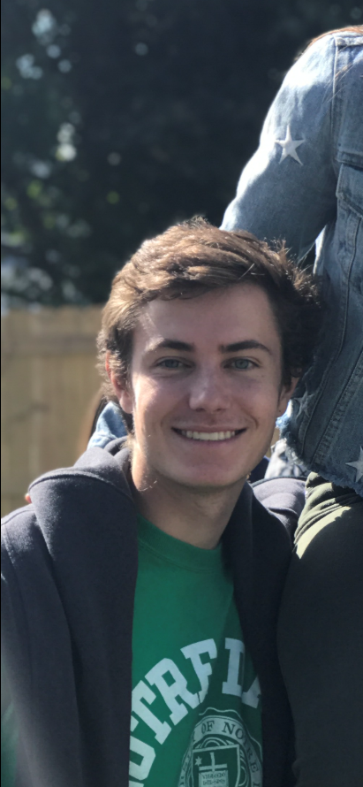

**Name:** MJ Haak

**Hometown:** Phoenix, AZ

**Major:** Finance/History

**Hobbies/Interest:** Lacrosse, skiing, dismantling the oppressive establishment board by board, time travel, fînànce

**Fisher Section:** Basement

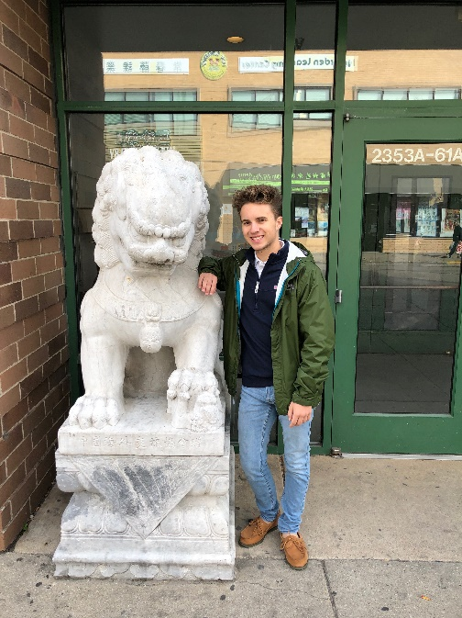

**Name:** Isaiah Metcalf

**Hometown:** Leesburg, IN

**Major:** Neuroscience and Behavior

**Hobbies/Interest:** Ben Shapiro, Capitalism, Fossil Fuels, and the Polar Vortex

**Fisher Section:** 4A

**Name:** Patrick Lanser

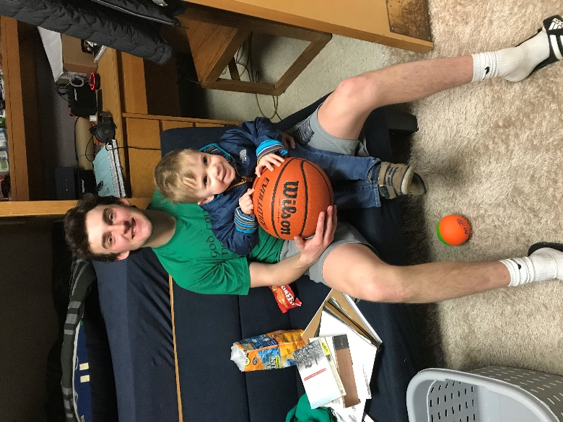**Hometown:** Wilmette, IL

**Major:** Finance and History

**Hobbies/Interest:** Discounted Cash Flow and Leverage Buyout Modeling, pumping iron, hanging out with my boys, and talking to Max Minicus about the Fed.

**Fisher Section:** 1A

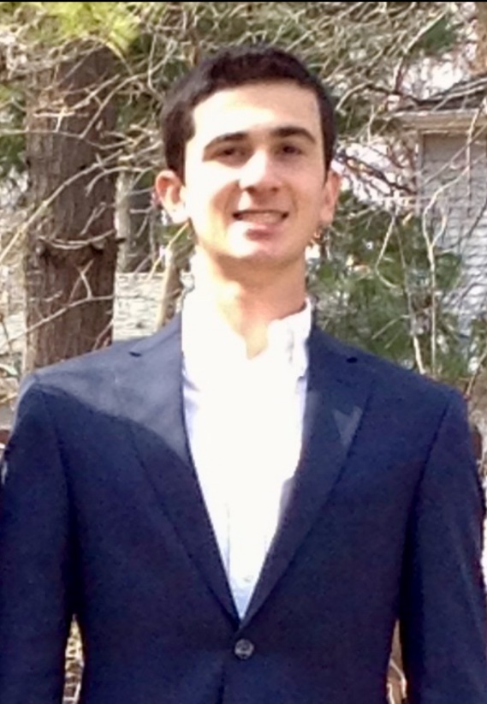

**Name:** Peter Kalemkerian

**Hometown:** Ann Arbor, MI

**Major:** Finance

**Hobbies/Interest:** New York Giants, Eli Manning, baseball, mini golf, fossil fuels

**Fisher Section:** 4A

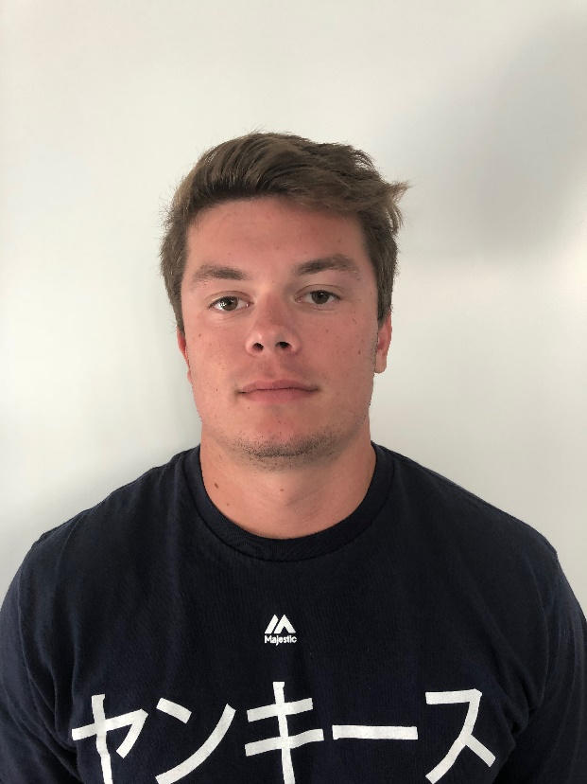**Name:** Pat Cummings

**Hometown:** Ridgewood, NJ

**Major:** Undecided Business

**Hobbies/Interest:** Sports, picking things up and putting them down, all-nighters in the basement study room, being Manbearpig, and caring way too much about ND football

**Fisher Section:** Basement

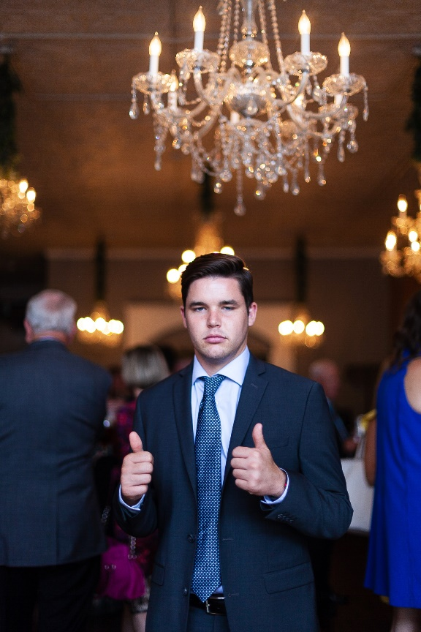

**Name:** Kyle Copley

**Hometown:** San Juan Capistrano, CA

**Major:** Civil Engineering

**Hobbies/Interest:** Indulging my iced coffee addiction, obsessing over architecture, and winning in Super Smash Bros.

**Fisher Section:** 1A

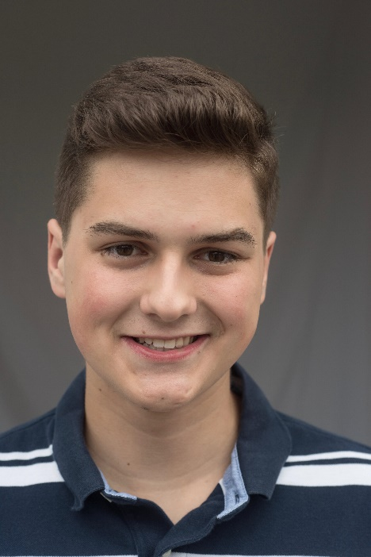**Name:** Jacob Mazur

**Hometown:** Elmwood Park, IL

**Major:** Electrical Engineering

**Hobbies/Interest:** Underwater basket weaving, eating salt for money, contraband philately, watching Pigglee Wigglee watch Meniscus find things in the dumpster out back, baking muffins

**Fisher Section:** 1A

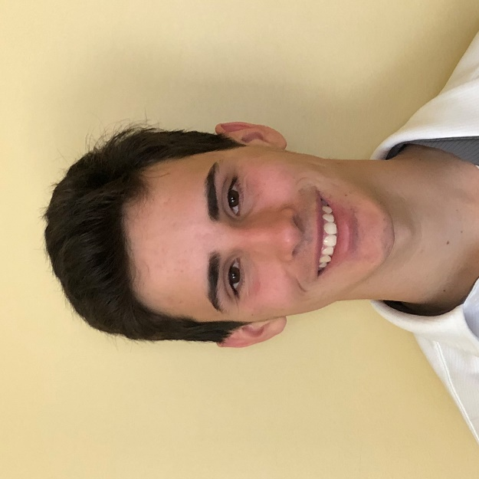

**Name:** Jack Masciopinto

**Hometown:** Mamaroneck, NY

**Major:** Computer Science/Econ

**Hobbies/Interest:** Basketball, Smash, Drinking Fisher Sink Water, Getting Massive in the Fisher Gym

**Fisher Section:** 4B

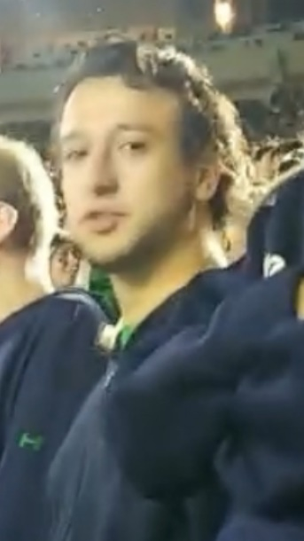 **Name:** Andrew Marquardt

**Hometown:** Western Springs, IL

**Major:** Chemical Engineering/Pre-Med

**Hobbies/Interest:** medium-difficulty sudoku enthusiast, apologist for the Birds Are Real campaign

**Fisher Section:** 4A

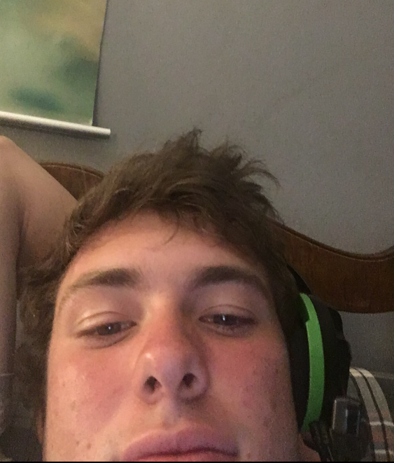

**Name:** Luke Murrison

**Hometown:** Boca Raton, FL

**Major:** Business Analytics

**Hobbies/Interest:** Magnets

**Fisher Section:** 2A

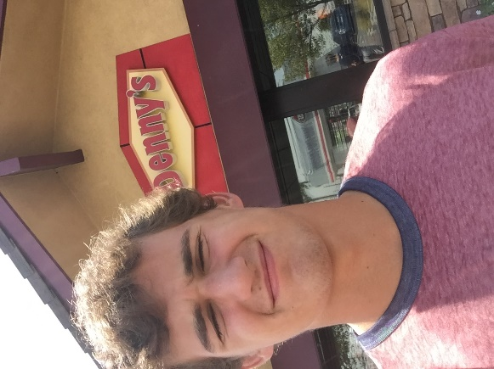

**Name:** Chris Nelson

**Hometown:** Cornelius, NC

**Major:** Business

**Hobbies/Interest:** Lax, Mendoza, steez

**Fisher Section:** 2A

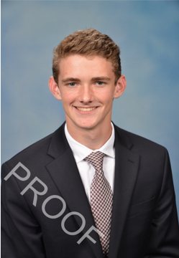

**Name:** John Murphy

**Hometown:** Garden City, NY

**Major:** Chemical Engineering

**Hobbies/Interest:** Liverpool FC, Fisher Sports, and Research

**Fisher Section:** Basement

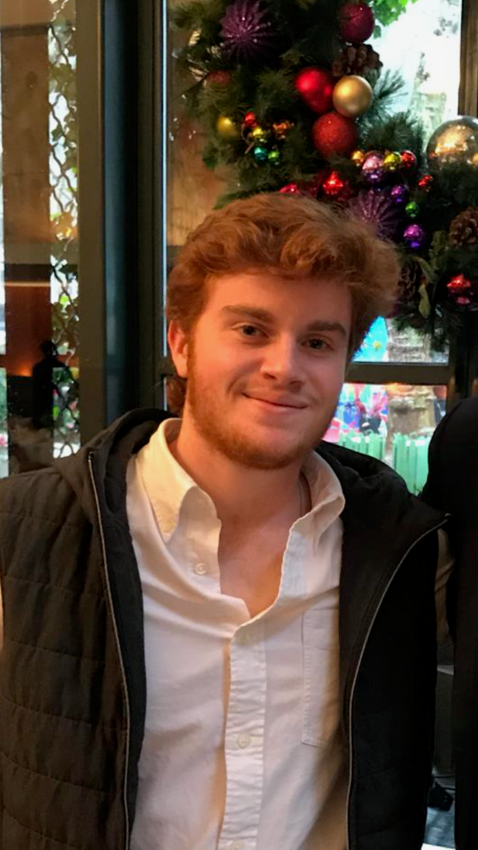

**Name:** Max Minicus

**Hometown:** Ridgewood, NJ

**Major:** Math, Philosophy

**Hobbies/Interest:** Guitar, recording music, reading, philosophy, politics, smash bros.

**Fisher Section:** 1A

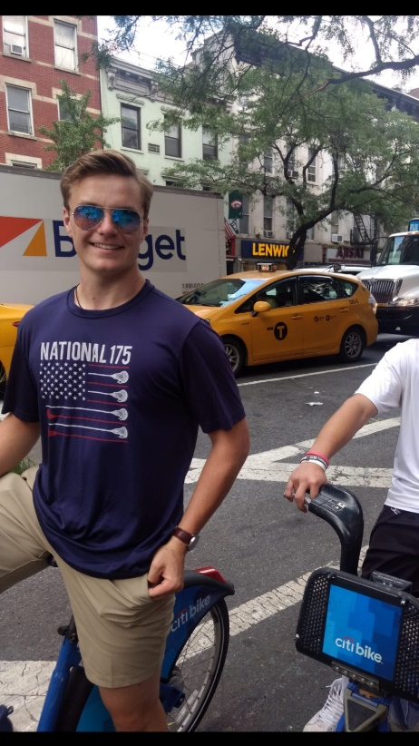

**Name:** Scott Deck

**Hometown:** Wayne, PA

**Major:** Mechanical Engineering

**Hobbies/Interest:** Sports, Robotics, Skiing

**Fisher Section:** Basement

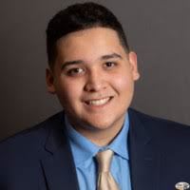**Name:** Oscar Magdaleno

**Hometown:** Chicago, IL

**Major:** Business Analytics

**Hobbies/Interest:** Basketball, Fortnite, Not Mr.Brightside

**Fisher Section:** 2B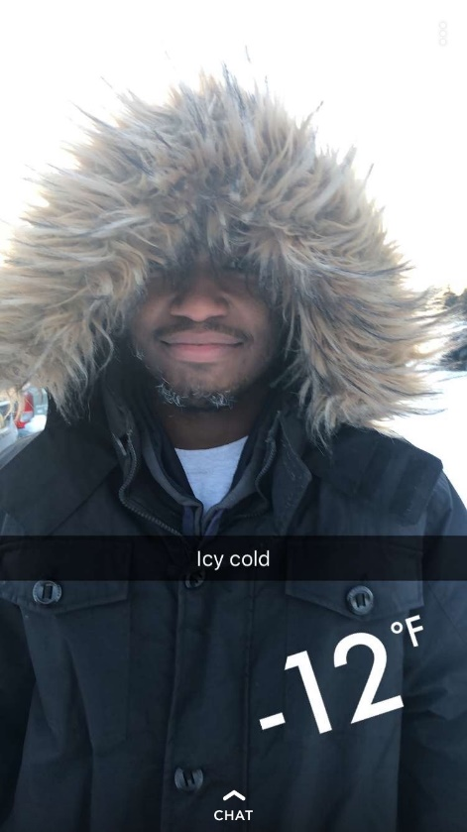

**Name:** Shamar Cousin

**Hometown:** Philadelphia, PA

**Major:** Sociology and English

**Hobbies/Interest:** Winning the Winter Classic, Ghost-riding the Wraith

**Fisher Section:** 3A

# 

# Rooms

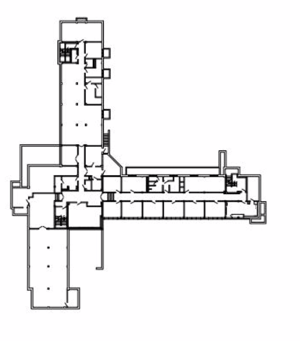

In Fisher Hall, First Years live in doubles with two closets and a sink, as well as modular furniture. This modular furniture consists of two beds, two wardrobes, and two desks, which are able to fit together in a variety of ways, including lofting and bunking. A typical arrangement can be seen in the images below.

Chapel

A Section

B Section

Additionally, each section has its own bathroom and shower room, and each floor has its own lounge and study room, with other study spaces on the first and basement floors.

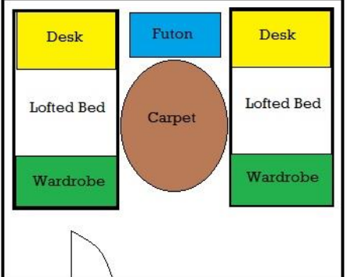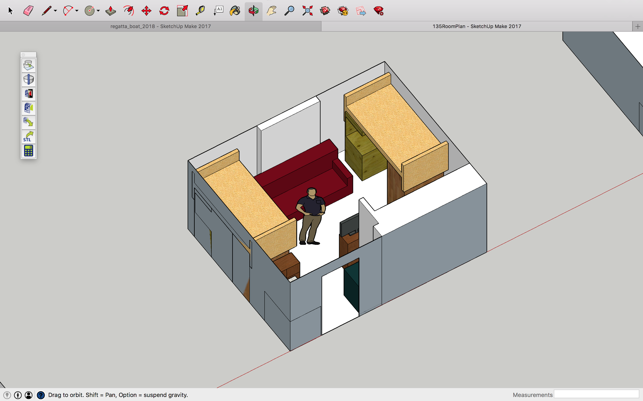

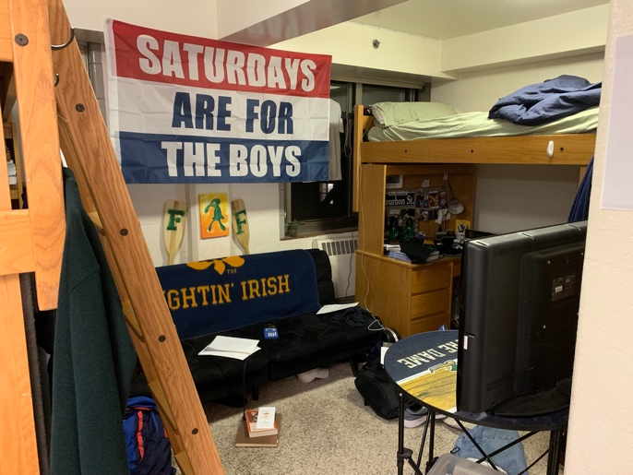*A typical arrangement in a double.*

*Amenities and Shared Spaces*

The Cadillac provides all the necessary amenities to ensure a healthy, happy, and comfortable lifestyle during your years here. Listed below are some of our fine offerings.

* **Billiards Room** – An air-conditioned 24-hour lounge (i.e. parietals do not apply to this space) in the basement complete with couches, flatscreen TV’s, a billiards table, a ping pong table, and Ellie’s Deli
* **Ellie’s Deli** – see page 22
* **Fred and Sally Room** – another of Fisher’s 24-hour lounges by the front door
* **Chapel** – The Chapel of St. Joseph hosts mass every Monday-Wednesday and Sunday at 10pm
* **Fisher Gym** – Fisher’s in-house gym complete with a squat rack, pull up bar, scale, bench press, treadmill, stationary bikes, punching bag, and dumbells
* **Laundry Room** – 6 washers, 12 dryers, an ironing station, a folding station, and a detergent vending machine
* **Study Rooms** – Fisher has a large rooms of study carrels and a reading room (“The Pit”) in the basement and a study room on each floor.
* **Vending Machines** – proving all the soft drinks and snacks Fishermen desire
* **Fisher Kitchen** – a complete kitchen with cookware and some basic ingredients
* **Elevator** – Fisher is handicapped accessible except for the basement rooms
* **Microwave** – shared microwaves in the basement and on the third floor
* **Section Restrooms** – each section has a men’s restroom
* **Private Restrooms** – private restroom for anyone especially non-male guests accessible through the Billiards Room or the Fred and Sally
* **Section Showers** – four individual showers
* **Cleaning and Maintenance** – Fisher is professionally cleaned and maintained regularly. Be sure to say hi to Saida, who helps keep Fisher clean!

*Packing*

While nothing can quite prepare you for Fisher’s greatness, a few essential supplies might help. Know that this list is just suggestions for informational purposes and in no way requirements.

**Good to have:**

* **Bedding** – residents bring their own sheets. Fisher beds are size twin extra-long. A mattress and frame are provided as well as a sideboard and ladder should you choose to loft or bunk your bed.
* **Shower shoes** – as showers are shared spaces, many residents wear some sort of flip-flops to the shower.
* **Futon** – many residents like to have a comfortable place to sit. Most furniture arrangements would fit a 5’-6’ wide futon / couch.
* **Shelving** – Fisher provides a dresser with a hanging rod and a sock drawer as well as a fully shelved desk. Bring extra shelving / storage if you would like.
* **Fan** – Fisher is not air conditioned, so the first week or so can be hot.
* **Bike** – This one is a very light suggestion. About one in ten Fishermen have a bike on campus. Skateboards, scooters, and the like are allowed as well.

**Not Necessary:**

* **Iron** – irons are available in the laundry room if you ever need it.
* **Extra lighting** – each room has a ceiling light and each desk has a light built in.
* **Extra cookware** – there is cookware in the kitchen and most of the meals you’ll have will probably be from the dining hall anyway.
* **Weights** – you can find these in the Fisher gym.
* **Microwave** – not allowed by Notre Dame. You can find shared microwaves on the 3rd floor and in the basement.

*There is a Target and a Bed Bath and Beyond near campus. BB&B’s “Pack and Hold” program allows you to order beforehand and pick up in Mishawaka.*

# Ellie’s Deli

At Fisher Hall, we hold food to a very high standard. As such, we are home to Ellie’s Deli, a food service in honor of the late, great Ellie (the dog of a former rector) that still makes the finest artisan paninis on campus from secret recipes. Located in the basement lounge, Ellie’s offers world-famous grilled cheese and other handcrafted sandwiches during late-night hours at modest prices. Run by Fishermen, for Fishermen, this counter provides the succulent snack that completes any night of work or fun.

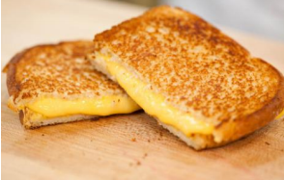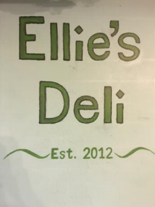

# Brother and Sister Halls: O’Neill and Pangborn

# 

Fisher Hall is friendly with everyone on campus, but O’Neill Hall and Pangborn Hall hold a special place in our hearts as our brother and sister halls, respectively. From BBQ’s to masses to dances to signature events, we support each other with mutual respect and community. Mazz is close friends with Father Chris (the rector of O’Neill) and we are close with the gentlemen of this larger dorm. Pangborn was formerly a “swing” dorm that would host the communities from dorms under construction. This year, however, Fisher’s next door neighbor welcomes an entirely new cast of young women who will have the unique task of building the Pangborn community from scratch. You will get a chance to meet our fine brothers and sisters in a variety of events during Welcome Weekend.

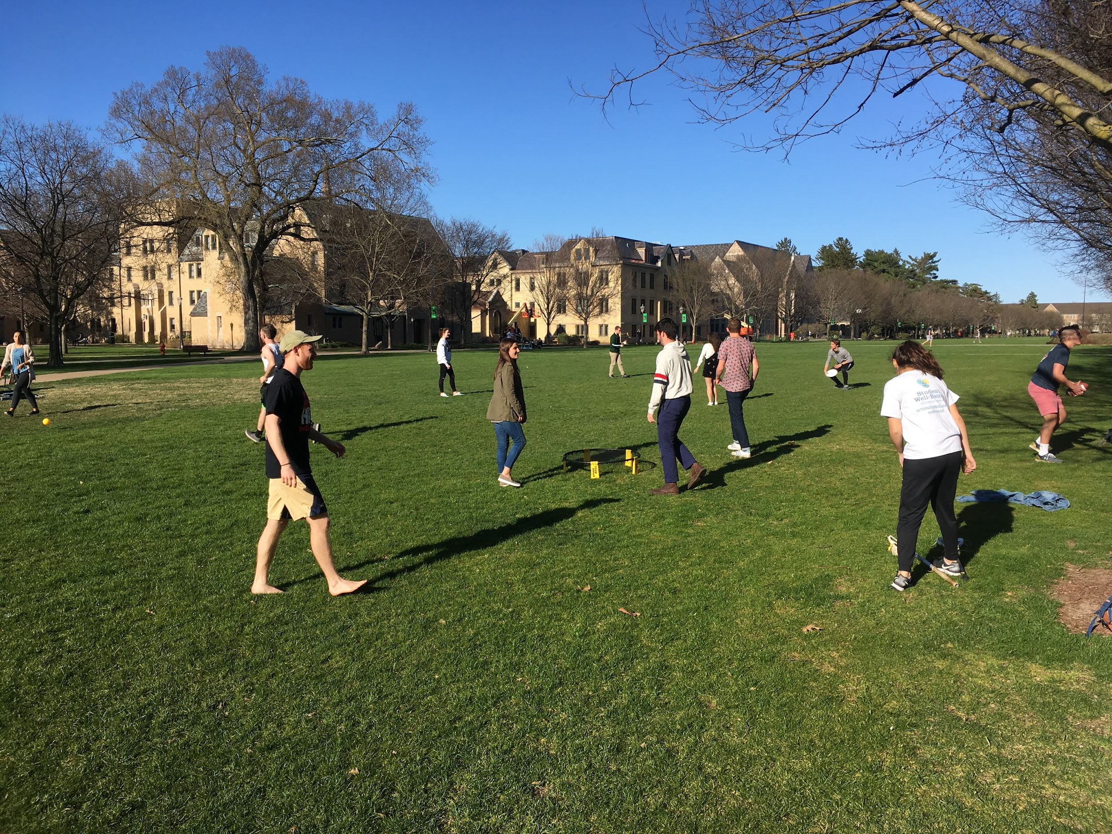

# Service

Fisher Hall is very passionate about its relationship with the community of South Bend. One of our most meaningful relationships is with St. Adalbert’s. This catholic elementary/middle school, located in a low-income area of the town, is truly near and dear to our hearts. In the past five years, through the Fisher Car Smash and the Fisher Regatta, we have donated $30,000 to our brothers and sisters at St. Adalbert’s helping to build a new gym floor, science lab, and computer lab. Fisher’s relationship with St. A’s extends far beyond fundraising, too. Many of the men of Fisher volunteer to tutor weekly at St. Adalbert’s. We have even hosted events with the children on campus and attended events on their campus as well. During welcome weekend, you will have the opportunity to visit St. Adalbert’s during the Day of Community and see the beautiful symbiosis between these two communities first hand.

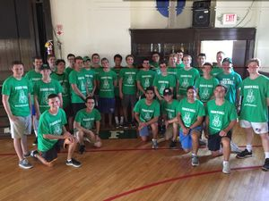

# Athletics

Fisher Hall bears a tradition of sportsmanship and competition in InterHall Sports. In the past few years, we have been especially dominant in Lacrosse, Hockey, Football, Baseball, and Tennis. Fishermen can also participate in a variety of other sports through Notre Dame RecSports.

Somewhat less competitive (but not really) is Spikeball, a game that Fisherman love to play right outside of Fisher on South Quad. You will certainly get ample opportunity to hone your skills so that you can take on the Seniors for bragging rights.

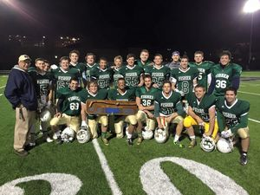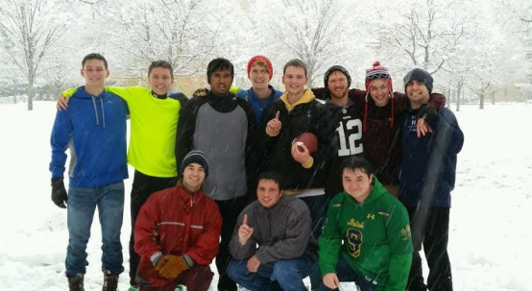

# Events: Fisher Funk

The Fisher Funk is our SYR (see jargon below), hosted in the Fall and loved/envied by everyone on campus. It is a chance to travel back in time, dress up in anything that looks remotely like it’s from the 70’s, and bowl with friends and dates. Embrace your inner hippie and just go with the flow. Mustaches and sideburns encouraged.

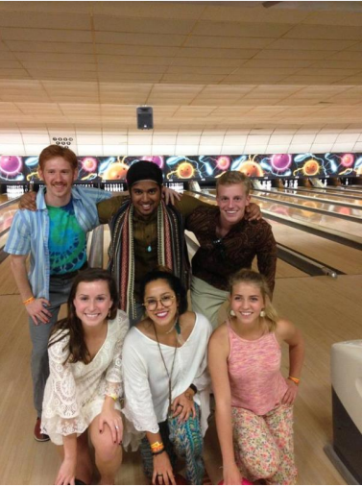

# Events: Fisher Regatta

The Fisher Regatta is our Signature Event, hosted in the Spring and considered by everyone in the world to be the greatest idea to grace the minds of men. Keenan Revue? Never heard of it. Keough Chariot Race? Never heard of it. But YA GOTTA REGATTA.

On the last Saturday of April, halls and clubs from across campus gather at St. Mary’s Lake to race against each other in hand-made boats. Fisher Hall organizes, runs, and participates in the event, all of the proceeds of which go to St. Adalbert’s. We have now made it commonplace to smash our fundraising goal with the 2019 Regatta maintaining the tradition as our efforts brought in $11,222. One of the Fisher boats, Floaty McFloatFace, has won the Fisher Regatta thus earning the ceremonial Golden Oar for three years straight. Will you be next?

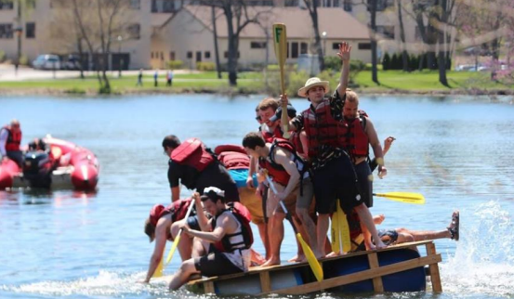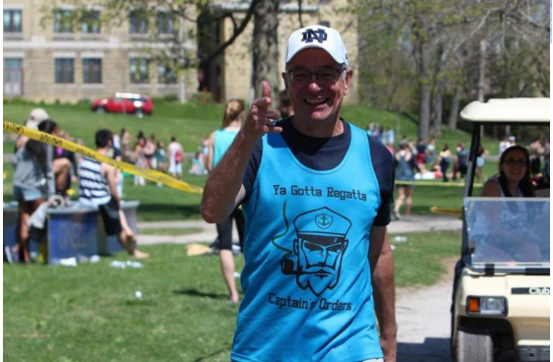

# ND Jargon Dictionary

AcoustiCafé: Performances by student musicians held every Thursday night in LaFortune Student Center

Archie: College of Architecture student, pronounced “Arkie”

Bengal Bouts: Student boxing tournament which occurs in February. All proceeds go to the Holy Cross Missions in Bangladesh.

Bookstore Basketball: Largest outdoor 5 on 5 basketball tournament in the world, held in April.

CSC: Center for Social Concerns; located by the library (Geddes Hall), the CSC is the location for information regarding service projects. Also has free coffee.

CHEG: Chemical Engineering student

Stonehenge: Peace memorial fountain located on Fieldhouse Mall (North Quad area)

CoMo: Coleman-Morse Center; On South Quad across from South Dining Hall, CoMo houses the First Year of Studies offices, Campus Ministry, the Writing Center, and a large study lounge.

DART: Old process of class registration. Replaced by NOVO.

DeBart: DeBartolo Hall; the main classroom building and is next to the stadium and the Snite Museum of Art

Dillon Hall Pep Rally: Dillon’s annual pep rally hosted on the Friday afternoon before the first home football game of the season and located in front of Dillon Hall on South Quad

Dome Dance: Special formal given to Hall of the Year, Men’s Hall of the Year, and Women’s Hall of the Year award winners.

Domer: Any Notre Dame student or graduate

Domer Dollars: Real money that is converted to Notre Dame-accessible funds

DPAC: The DeBartolo Performing Arts Center, located at the end of DeBartolo Quad. This giant building houses a concert hall, theater, organ hall, TV studio, and movie theater and features performances throughout the year.

DuLac: Document which lists the rules of life and conduct at Notre Dame

D-2: Resident student parking lot near Mod Quad

D-6: Resident student parking lot located by the Campus Security building

Fieldhouse Mall: Site of the former fieldhouse, near LaFortune Student Center and North Quad, now contains the Clarke Memorial Fountain (“Stonehenge”)

Fisher Formal: Formal dance held traditionally (for the past two years) in the Rock.

Fisher Funk: Fisher’s fall “dance”. The entire dorm dresses in 70s themed clothing and enjoys an evening of bowling and music with their dates at Chippewa Bowl.

Fisher Regatta: Hosted by Fisher Hall, the Regatta is the annual boat race held on St. Mary’s Lake during the spring semester. By far the best signature event on campus, and perhaps the world.

Flex Points: Monetary credit (1 Flex Point = $1.00) accepted at campus meal locations such as Subway and Reckers

Grab ‘n Go: Campus meal option offered in both dining halls which provides a sack meal to students who don’t have time to eat in the dining hall. Take note: North and South Dining Hall actually offer different Grab ‘n Go options.

Holy Cross College: Liberal arts college across the street, also founded by the Congregation of Holy Cross like Saint Mary’s and Notre Dame

Huddle: Place to get food and meet friends. Located in LaFortune Student Center

insideND:Website that facilitates class registration (NOVOing) and web enrollment, and allows students to access final class grades and class schedules

JACC: Joyce Athletic and Convocation Center, acronym pronounced “Jack”. The JACC is the home to many varsity athletics, concerts, and commencement ceremonies.

John Jenkins: The President of the University, Fr. John Jenkins, CSC.

JPW: Junior Parents Weekend; weekend in February exclusively for juniors and their parents

Keenan Revue: Comedy show performed by the residents of Keenan Hall and held during the spring semester

Keough Hall Chariot Race: Chariot race held during the fall semester and sponsored by Keough Hall.

LaFun: LaFortune Student Center which contains SmashBurger, Subway, Starbucks, Taco Bell, Pizza Hut, a hair salon, florist shop, barber shop, copy shop, travel agency, credit union, computer lab, and offices.

Legends: Restaurant, Bar, and Dance Club located near the stadium. Also a concert venue that has brought Aziz Ansari, Twenty-One Pilots, Borns, Smallpools, and others.

Monk: Nickname for Notre Dame’s former-president, Father Edward A. Malloy, CSC

NDH: North Dining Hall: the lesser of the two dining halls

NDSP: Notre Dame Security Department

NOVO: System students use to stressfully register for classes at the end of each semester

O’Shag: O’Shaughnessy Hall; Headquarters and main classroom building for the College of Arts & Letters, includes Waddick’s Café

The Observer: Daily campus newspaper published Monday-Friday, famous for its Viewpoint section, which features letters to the editor.

OIT: Office of Information Technologies Central agency responsible for computing services on campus

Parietals: Visitation hours for guests of the opposite sex in student dorms

Quarter Dogs: Hotdogs sold for $0.25 at midnight every night in LaFun

Reckers: 24-hour café located behind South Dining Hall

The Rock: Rockne Memorial; Student athletic facility located on the west end of South Quad that includes an Olympic-size swimming pool, basketball, handball, and racquetball courts, and aerobics and weight training rooms

Sakai: Website for professors and students for grades, home-

work, and feedback.

SMC: St. Mary’s College; Women’s college across the street from Notre Dame, also started by the Congregation of Holy Cross like Notre Dame and Holy Cross College, acronym pronounced “Smick”

Scholastic: Campus magazine

SDH: South Dining Hall, the greatest food serving establishment at Notre Dame

The Shirt: Annual T-shirt that celebrates the football season and is worn by the students to the football games. Buy it!

Stepan Center: Venue used for concerts and similar events on the North end of campus

Stallnotes: Occasional publication found in Fisher Restrooms that is half news, half attempted humor. Called the “Stall Street Journal”

SUB: Student Union Board; Student group responsible for bringing concerts, speakers, and movies to campus. They also organize AcoustiCafé.

SYR: Semi-formal dance held by every dorm. Stands for outdated term “Setup Your Roommate.”

TA: Teaching Assistant

# Nearby Stores/Restaurants

• Bar Bici Italian Street Food- 1233 N Eddy St, South Bend 574-251-1330

• Bonefish Grill - 620 W Edison Rd– Mishawaka 574-259-2663

• Carraba’s – 210 W Day Rd (off Grape Rd) – Mishawaka 574-247-9460

• Chili’s Bar and Grill - 4810 Grape Rd. – Mishawaka 574-271-1330

• Chipotle – 1251 North Eddy Street (right across from campus) 574-251-0175

And 5445 N. Main St. – Mishawaka 574-271-3353

• Cold Stone Creamery - 620 W. Edison Rd. – Mishawaka 574-257-7884

• Famous Dave’s – 6402 Grape Rd. – Mishawaka 574-277-1888

• Five Guys (burgers and fries) – 1233 North Eddy Street (right across from campus) 574-234-1800

• Le Peep (breakfast and brunch) – 127 S. Michigan St. – Downtown South Bend 574-288-7337

• Max & Erma’s – 4340 N. Main St. – Mishawaka 574-243-5600

• Olive Garden - 6410 Grape Rd. – Mishawaka 574-277-6503

• Outback Steakhouse - 4611 Grape Rd – Mishawaka 574-271-2333

• Panera – 4310 N. Main St. – Mishawaka 574-243-0001

• Papa Vino’s -5110 Edison Lakes Pkwy - Mishawaka, IN 574-271-1692

• Ritter’s Frozen Custard (half price with a student ID!) – 3921 N. Main St. – Mishawaka 574-255-8000

• Soho Japanese Bistro – 7225 Heritage Square Drive-Granger 574-272-2292

• Super Target - 155 University Dr. Mishawaka (Across from University Park Mall) 574-243-7442

• Bed, Bath, and Beyond - 5802 N. Grape Rd. Mishawaka 574-271-0709

• University Park Mall- 6501 Grape Rd. Mishawaka 574-277-2223

• Martin’s (Grocery Store) – 2081 S. Bend Ave, South Bend 574-272-6922

• Meijer (Grocery Store) - 5020 Grape Rd, Mishawaka 574-273-3500

• Sam’s Club - 120 Indian Ridge (Off Grape Rd.) Mishawaka 574-243-8048

• Wal-Mart- 316 Indian Ridge (Off Grape Rd.) Mishawaka 574-243-9188

# Useful Websites

[Fisher Hall](https://fisher.nd.edu/)

[InsideND](https://inside.nd.edu/)

[Sakai](https://sakai.nd.edu/)

[OIT](https://oit.nd.edu/)

[Counseling Center](https://ucc.nd.edu/)

[McWell](https://mcwell.nd.edu/)

[RecSports](https://recsports.nd.edu/)

[Welcome Weekend](https://welcomeweekend.nd.edu/)